**Ardeen Road United Reformed Church**

**Doncaster**

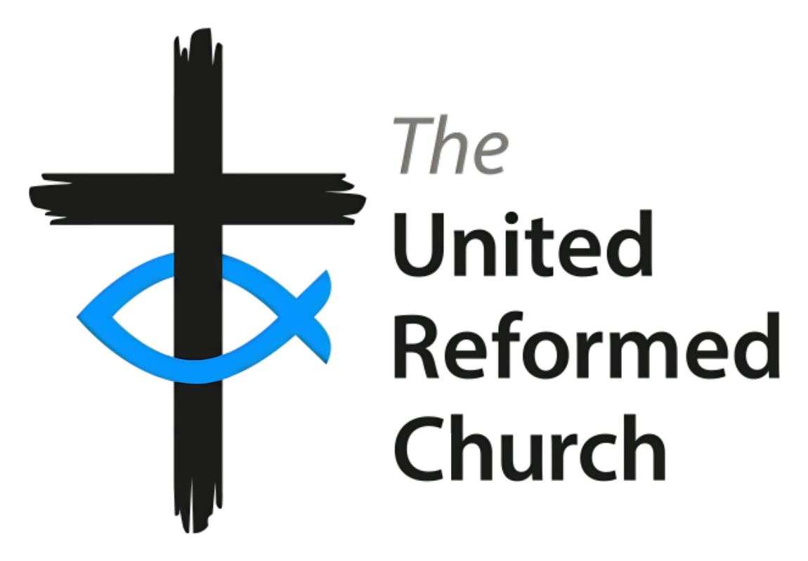

**SAFEGUARDING POLICY**

The following statement was agreed by the Church Meeting of Ardeen Road United Reformed Church, Doncaster.

We define safeguarding as the promotion of the safety and welfare of children and adults who are at risk of, or experiencing, harm, abuse or neglect in all forms. We acknowledge children’s and adults’ right to protection from any form of abuse or neglect regardless of age, gender reassignment, race, disability, sexual orientation, religion or belief, marriage/civil partnership, pregnancy and maternity. Therefore, as members and workers of the church, we are committed to

* the care and nurture of all children and adults,
* the safeguarding and protection of all children and adults at risk
* the establishment of a loving church environment which is safe and caring for all people and where the dignity of each person is respected.
* an informed vigilance about the dangers of all forms of abuse, harm and neglect within all aspects of work in the Church, and how to respond appropriately,
* organising activities in such a way as to promote a safe environment and minimise the risk of harm to children and adults.
* ensuring everyone who engages with the life of the Church is responsible for keeping people safe,
* working together with voluntary/statutory agencies and other denominations and faith-based organisations.

We recognise that we all have a responsibility to help prevent any form of abuse and neglect of children and adults and to ensure the wellbeing and pastoral care of those who are, or may be, at risk.

We will seek to prevent abuse related to extremism or radicalisation and put all suitable health and safety arrangements in place as well as safeguarding, first aid, fire safety and online safety policies that everyone understands.

We will strive to create and maintain a safe and inclusive environment for all, especially children and adults at risk, in which the dignity and rights of each person are respected.

We believe that domestic abuse in all its forms is unacceptable, inconsistent with a Christian way of living and it can affect both adults and children.

We will always acknowledge that the welfare of the child and adult at risk is paramount, and that the priority is always to act in their best interests, following legislation, statutory guidance and recognised good practice guidance to enable them access to support and protection.

We will support everyone to ensure that as a community of Christians we will all work within the agreed procedures of our safeguarding policy and related policies (Safer Recruiting Policy, Lone Worker policy, GDPR Policy). We will appoint a Safeguarding Co-ordinator and a Deputy Safeguarding Co-ordinator who will have specific responsibilities for safeguarding, although we recognise that safeguarding is a whole church responsibility The Safeguarding Co-ordinator or the Deputy Safeguarding Co-ordinator (when available) are the persons to whom all concerns or allegations should be addressed for appropriate actions to be taken. In the absences of the Safeguarding Coordinator or deputy the Synod Safeguarding officer should be contacted. Their contact details are always available on our posters, websites or other communications with the public.

We will exercise proper care in the appointment and selection of Elders/trustees and those who will work with children or adults at risk within the Church, whether paid, volunteers, lay or ordained according to our safer recruiting policy. We will ensure that Elders/trustees, staff and volunteers are suitable and legally able to act in their positions. We will use DBS/PVG checks as part of a wide range of checks on Elders/trustees, staff and volunteers to ensure that we have a broad and informed view to assist us in minimising the risk of abuse, harm or neglect.

We will support, supervise, resource and train all those who undertake work with children and adults in need of protection.

We will respond without delay to every concern, incident or complaint which suggests that a child or adult has been harmed, or is at risk of harm, and cooperate with ecumenical partners, the Police, the Designated Officer (DO , formerly known as LADO), Local Safeguarding Boards (in Wales), Children’s Partnership Boards (formally Local Safeguarding Children’s Boards) and Children’s and Adult Social Care Services in any investigation, while maintaining the confidentiality of any investigations to those directly involved.

We are committed to working with those who have suffered or suffer any form of abuse, offering appropriate pastoral support where possible as well as challenging any abuse of power, especially where it involves someone in a position of trust.

We will manage risks and those who might pose a risk to the welfare of people and the life of the Church and offer support to those known to pose a risk to children and/or adults, including supervision, referral to the appropriate agencies, and implementation of safeguarding contracts, when appropriate.

We are committed to ensuring that any allegations, concerns and complaints about abuse or neglect are recorded accurately, reported promptly and shared safely within and outside of the denomination, including referring to the statutory authorities if necessary.

We will refer concerns about staff – volunteers and paid, lay and ordained – that meet the relevant criteria to the Local Authority Designated Officer.

We will review our safeguarding policy, practices and procedures annually, considering lessons learned from safeguarding cases and changes in legislation, statutory guidance and good working practice.

We will ensure processes and practices in all aspects of safeguarding, including discipline, risk management, whistleblowing and bullying/harassment are in alignment with Good Practice 6 – the United Reformed Church’s policy and guidance in safeguarding children, young people and adults at risk.

Any local policy changes will be formally approved by the local church Elders/ trustees.

**Key Contacts**

The church Safeguarding Coordinator is the person to whom all concerns or allegations relating to children, young people or adults should be addressed:

Name Ailsa Johnson

Telephone No 07973296188

Email [ailsa.johnson@blueyonder.co.uk](mailto:ailsa.johnson@blueyonder.co.uk)

In the absence of the Safeguarding Coordinator, the Deputy Safeguarding Coordinator can be contacted:

Name Rod Morrison

Telephone numbers 07806916917

01302 530109

Email [rodmorrison1946@btinternet.com](mailto:rodmorrison1946@btinternet.com)

Synod Safeguarding Officer

Name Matt Knowles

Telephone No 07761525592

Email [matt.safeguarding@urcyorkshire.org.uk](mailto:matt.safeguarding@urcyorkshire.org.uk)

• URC Safeguarding Office (This should only be used if you are unable to contact your Synod Safeguarding Officer) Telephone No 020 7520 2729 Email safeguarding@urc.org.uk

This policy applies to:

* all those who attend our church.
* our Elders, some of whom act as trustees and staff (both paid and voluntary)
* organisations who hire our building with agreement to operate under the church safeguarding policy.

The Elders/Trustees will review this policy annually, amending and updating it as required, and informing Church Meeting that this has been done.

Date of the most recent review: 7.2.24 Date of the next review: 7.2.25

Signed:

on behalf of the church Elders